**1 INTRODUCTION**

* 1. A BRIEF DESCRIPTION ABOUT PROJECT

Project Topic:

Subscriber’s Galore: Exploring World’s Tops YouTube Channels 

1. First is brain storming and creating an empathy map.
2. Next download the tableau app.
3. First recording the data sets in the tableau.
4. Next create seven sheets and give a heading in each sheet and pie-charts for those data sets. They are,

Rank wise channel

No of channels with brand

Channel brand

Channel name with subscribers

No of channels of a language

Category wise language

Country and language

Language wise subscribers

Country wise subscribers

Language wise subscribers

1. Next create a dashboard with the created sheets. We have created five types of dashboard.
2. Finally create a story.
   1. Purpose of this project

What we have mentioned in this program is exploring the best YouTube channels in the World. The benefit in this scheme can be divided into two categories. They are ,

One is that there is a benefit to the subscriber’s.

For example: Subscribers benefit from searching YouTube for what they need.

Another is the benefit for YouTubers.

For example: YouTubers personalities come out and prove who they are to the world.

1. PROBLEM DEFINITION &DESIGN THINKING
   1. EMPATHY MAP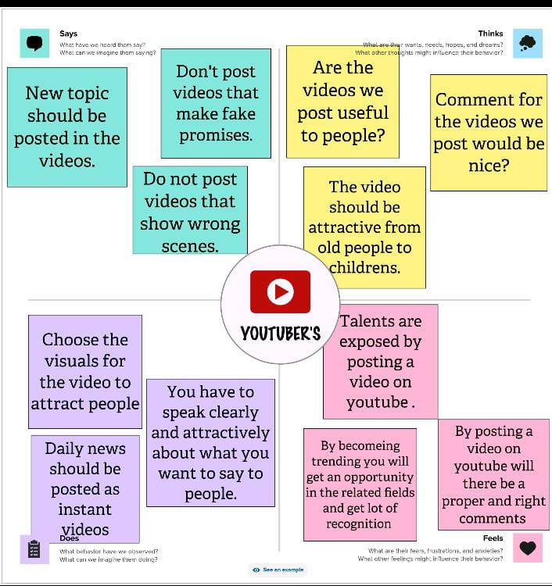

* 1. IDEATION & BRAINSTORMING

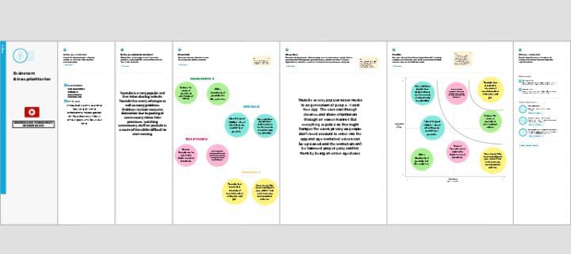

3 result

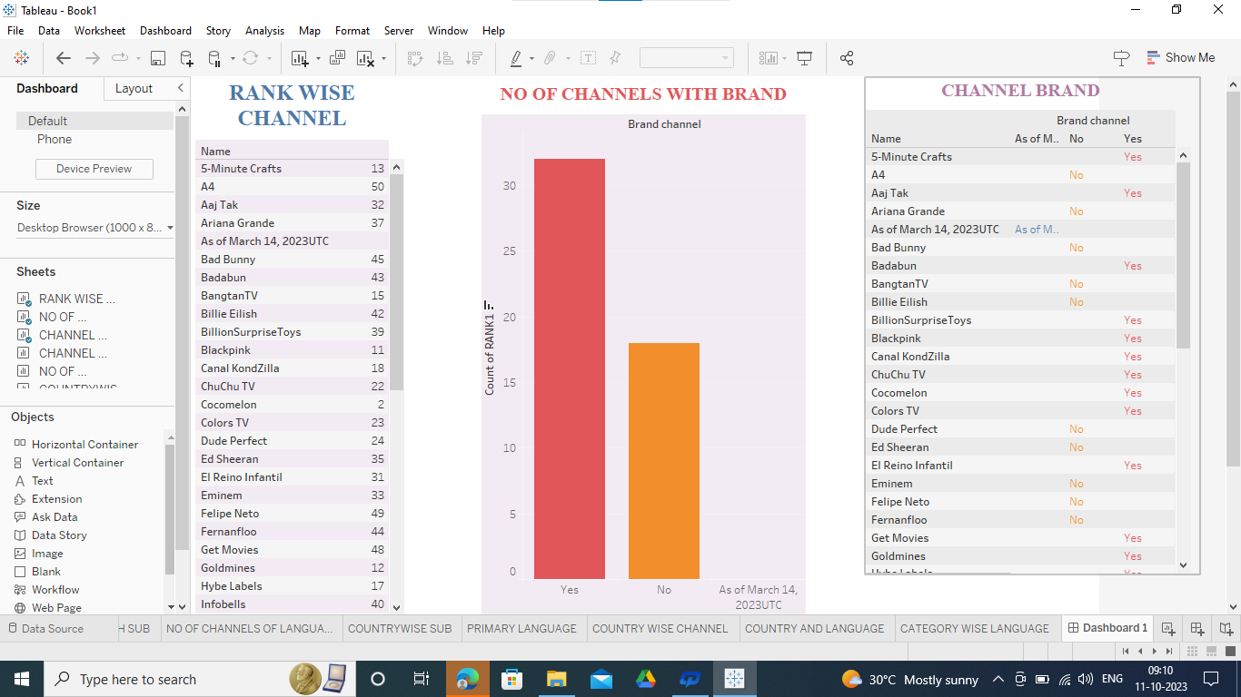

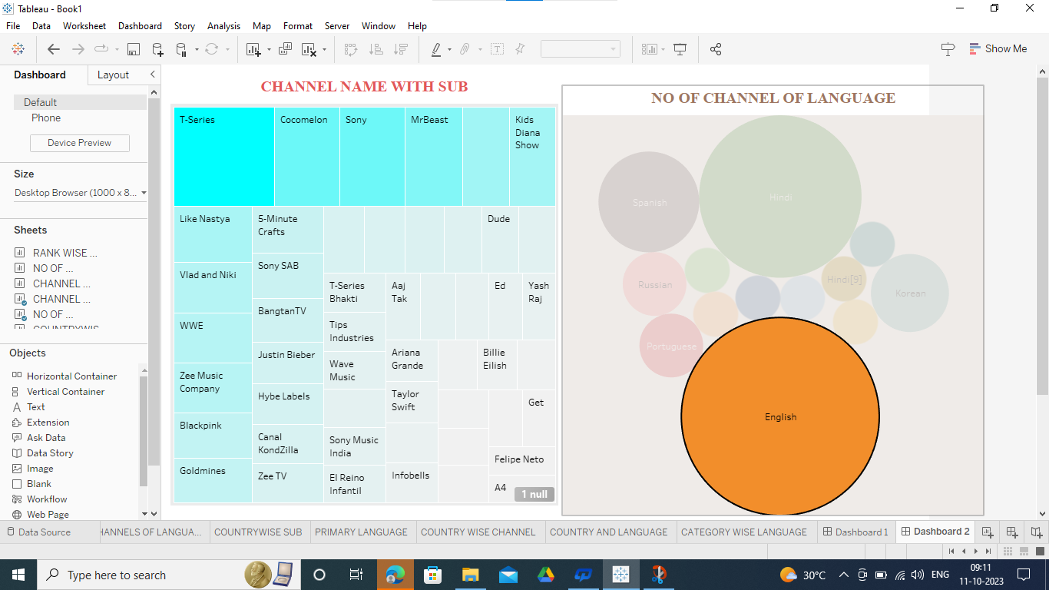

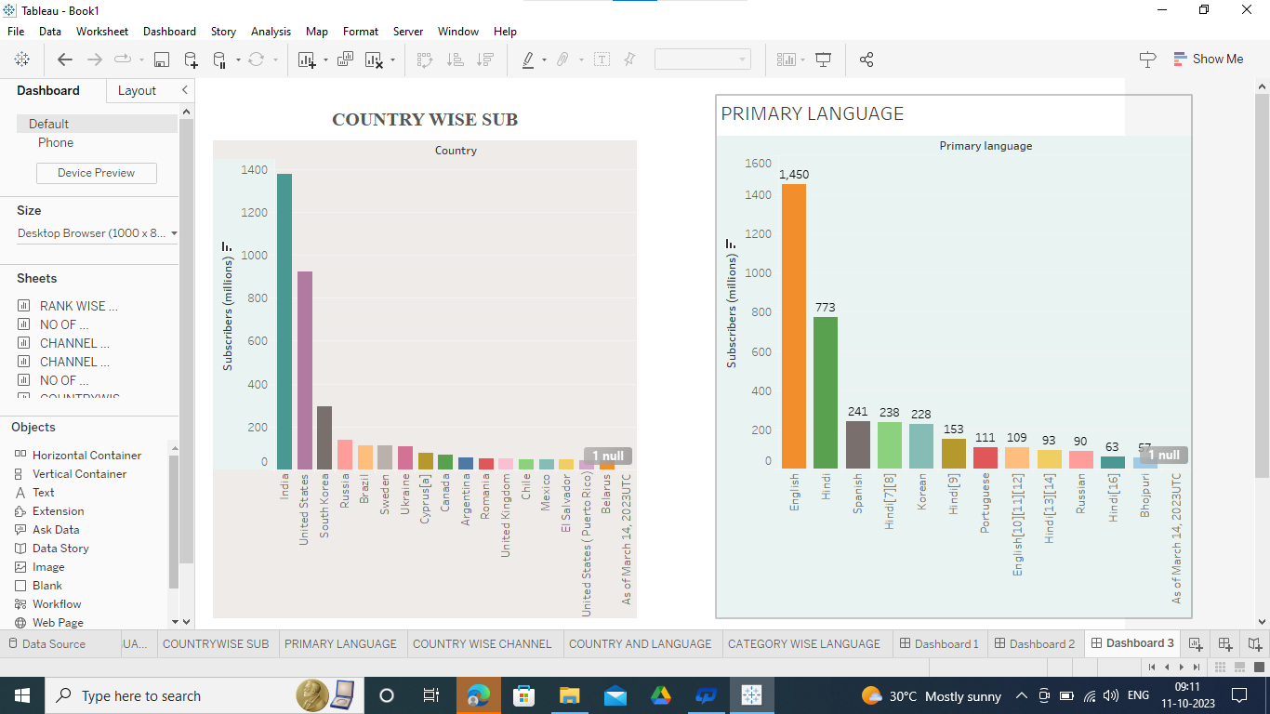

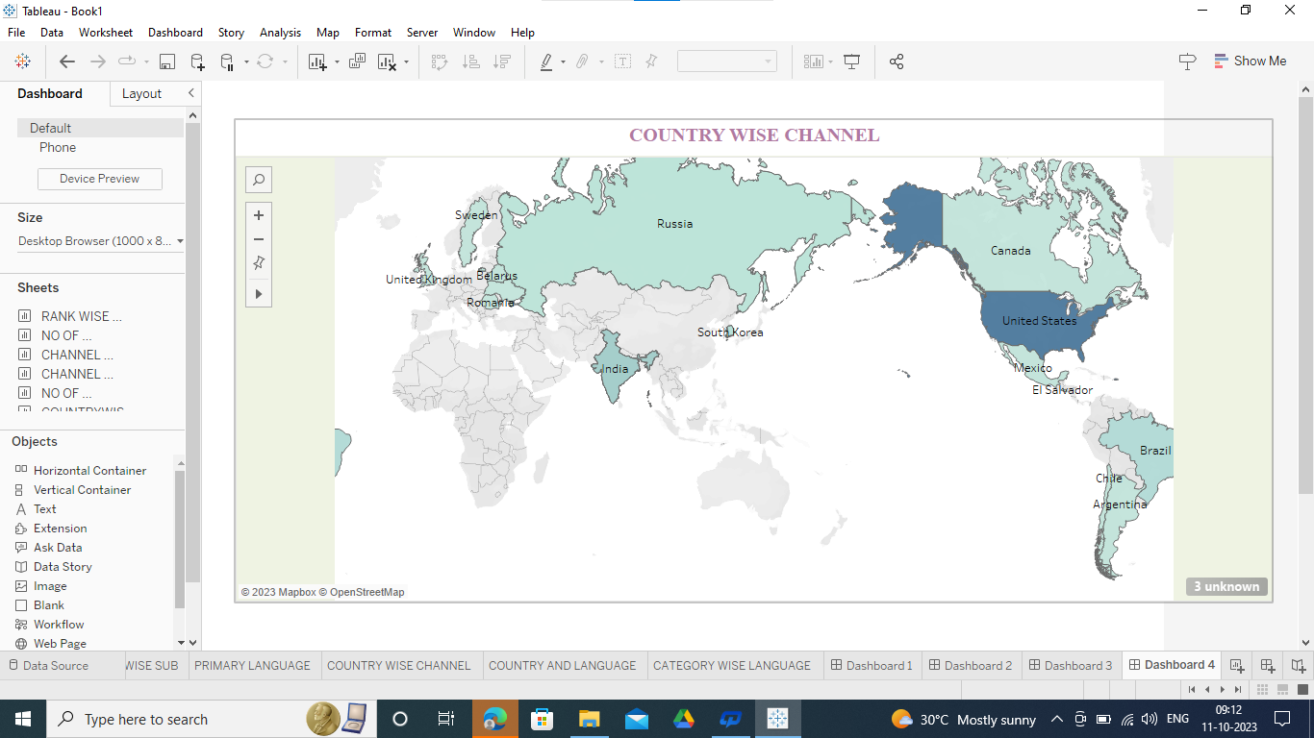

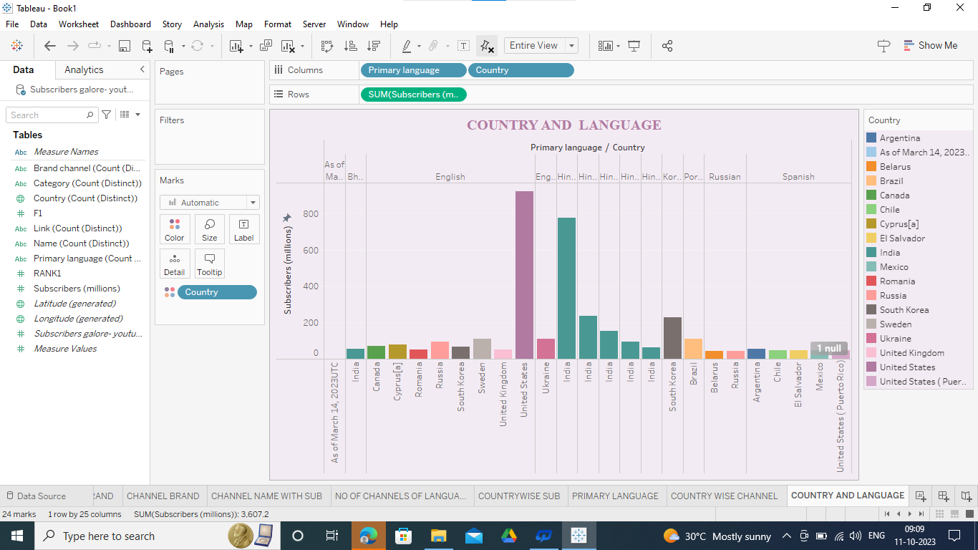

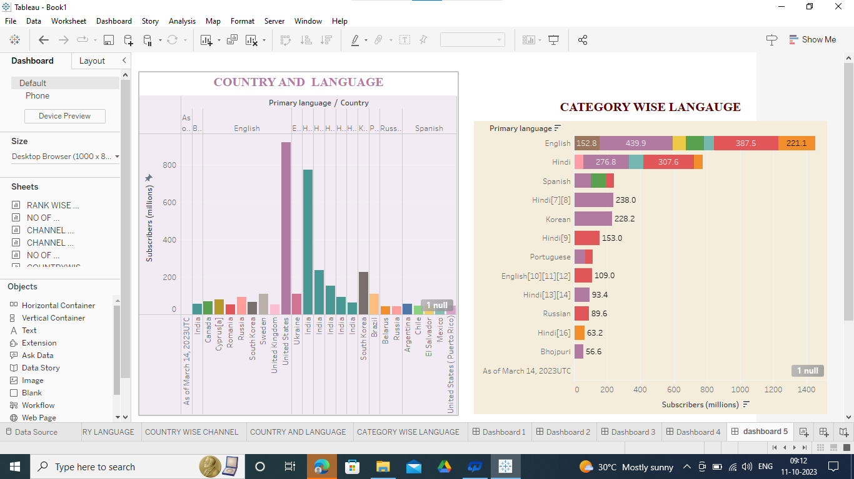

Result:

* All of the above using for students extra knowledge,new project ideas and get more new thinking.



1. ADVANTAGES & DISADVANTAGES

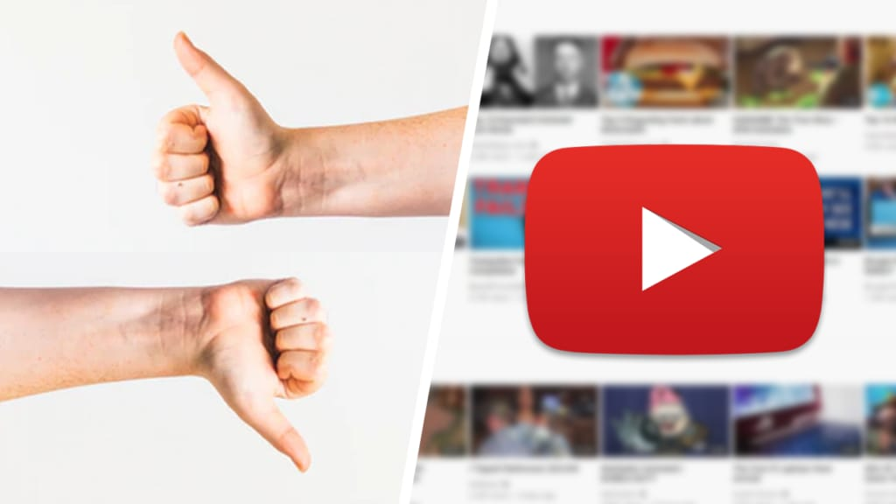

ADVANTAGE OF A YOUTUBE CHANNEL:

* Starting a YouTube channel gives your audience access to more of your content.
* If you already use view marketing strategy, a YouTube channel gives you a centralized location to past advertisement , informational content and entertainment videos.

DISADVANTAGE OF YOUTUBE CHANNEL:

* Obscenity of the biggest drawbacks that YouTube has,

Since YouTube is a no-cost and accessible platform for anymore, children are attracted to watching videos with explicit language and obscenity.

* The use of explicit image and words is common now a days.

5 applications

* Use “ Power Playlists”
* Publish Long Videos
* Promote Videos In Your End Screen
* Add a Brand Watermark
* Focus On Video Quantity
* Create a Channel Tagline
* The Social Media Preview
* Include a Subscribe Link in Your Channel Art

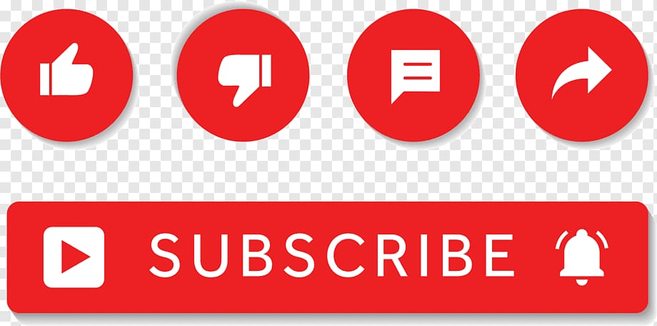

6 conclusion



* This study has several limitations one of which is the same size. In spite of the small sample of only six videos. It was possible to understand which educational contents is being shared in the videos.
* For future research it is suggested,

To develop similar studies with larger sample.

To focus on all the type of videos shared by scholars and

To analyse and compare all the videos of selected scholars uploaded under the YouTube category “education”.

7 future scope



* YouTube is ever-changing, whether it’s “borrowing” features from other platforms, finding new ways to monetize, or making the platform more accessible to creators and viewers . If YouTube continues on the current path, the future will include more streaming, more eCommerce initiatives, and more immersive experience.

OUR EXPERIENCE:

This is new experience for us. We learned a lot of information through this. Thank you for this opportunity.



THANK YOU